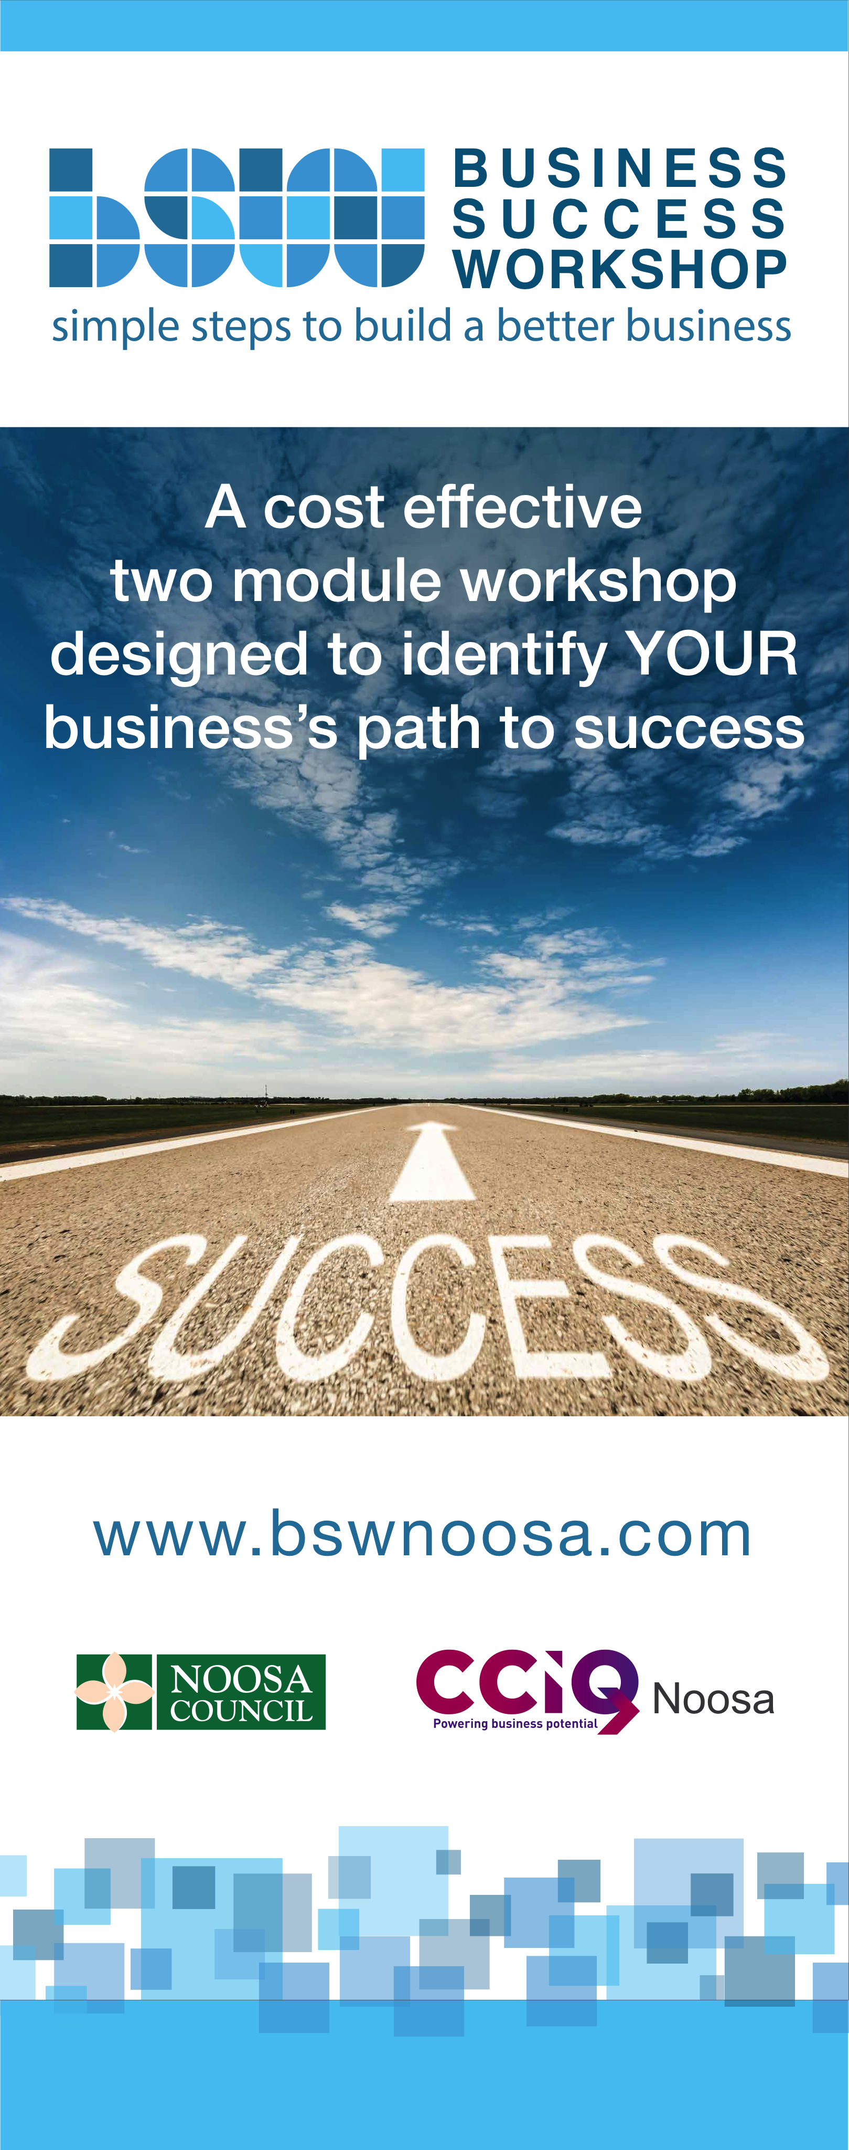
List of Possible Values
Abundance | Acceptance | Accuracy | Achievement
Adaptability | Adventure | Affluence | Agility
Ambition | Appreciation | Assertiveness | Assurance
Astuteness | Attentiveness | Audacity | Authenticity
Awareness | Balance | Beauty | Benevolence
Boldness | Bravery | Calmness | Camaraderie
Candor | Capability | Carefulness | Caring
Certainty | Challenge | Charm | Cheerfulness
Clarity | Cleanliness | Commitment | Compassion
Composure | Confidence | Congruency | Consciousness
Consistency | Contentment | Contribution | Control
Conviction | Cooperation | Courage | Creativity
Credibility | Curiosity | Decisiveness | Dependability
Desire | Determination | Diligence | Direction
Discipline | Drive | Economy | Education
Effectiveness | Efficiency | Empathy | Encouragement
Energy | Enjoyment | Enthusiasm | Excitement
Expertise | Fairness | Faith | Financial Independence
Fidelity | Firmness | Fitness | Flexibility
Focus | Forthrightness | Fortitude | Frankness
Friendliness | Frugality | Fulfillment | Fun
Generosity | Genius | Giving | Gratitude
Growth | Happiness | Health | Helpfulness
Honesty | Hopefulness | Humility | Humor

Imagination | Independence | Indomitable | Ingenuity
Innovative | Inquisitiveness | Insightfulness | Inspirational
Integrity | Intensity | Intimacy | Intuition
Inventiveness | Joy | Judgment | Kindness
Knowledge | Leadership | Leverage | Liveliness
Logic | Longevity | Loyalty | Maturity
Mindfulness | Modesty | Motivation | Neatness
Nurture | Openness | Optimism | Passion
Patience | Peace | Persistence | Persuasiveness
Philanthropy | Playfulness | Poise | Potency
Power | Practicality | Pragmatism | Precision
Preparedness | Presence | Proactivity | Professionalism
Progress | Prosperity | Punctuality | Reasonableness
Realism | Recognition | Relaxed | Reliability
Resilience | Resolve | Respect | Resourcefulness
Restraint | Risk | Sacrifice | Satisfaction
Security | Selective | Self Belief | Self Awareness
Self Esteem | Self Honesty | Self Control | Sensitivity
Serenity | Simplicity | Sincerity | Skillfulness
Spirituality | Spontaneity | Stability | Strength
Supportive | Thankfulness | Thoroughness | Transformational
Trust | Trustworthy | Truth | Truthfulness
Understanding | Vision | Vitality | Warmth
Winning | Wisdom | Wonder | Youthfulness

My Core Values

SWOR

Strengths | Weaknesses
Opportunities | Risks

My USP

My Vision

My Strategic Essentials

Strategic Essential :

Goals |  | Tasks |  | Responsibilities
1)
2)
3)
4)
5)

Strategic Essential :

Goals |  | Tasks |  | Responsibilities
1)
2)
3)
4)
5)

Strategic Essential :

Goals |  | Tasks |  | Responsibilities
1)
2)
3)
4)
5)

Strategic Essential :

Goals |  | Tasks |  | Responsibilities
1)
2)
3)
4)
5)

Strategic Essential :

Goals |  | Tasks |  | Responsibilities
1)
2)
3)
4)
5)

